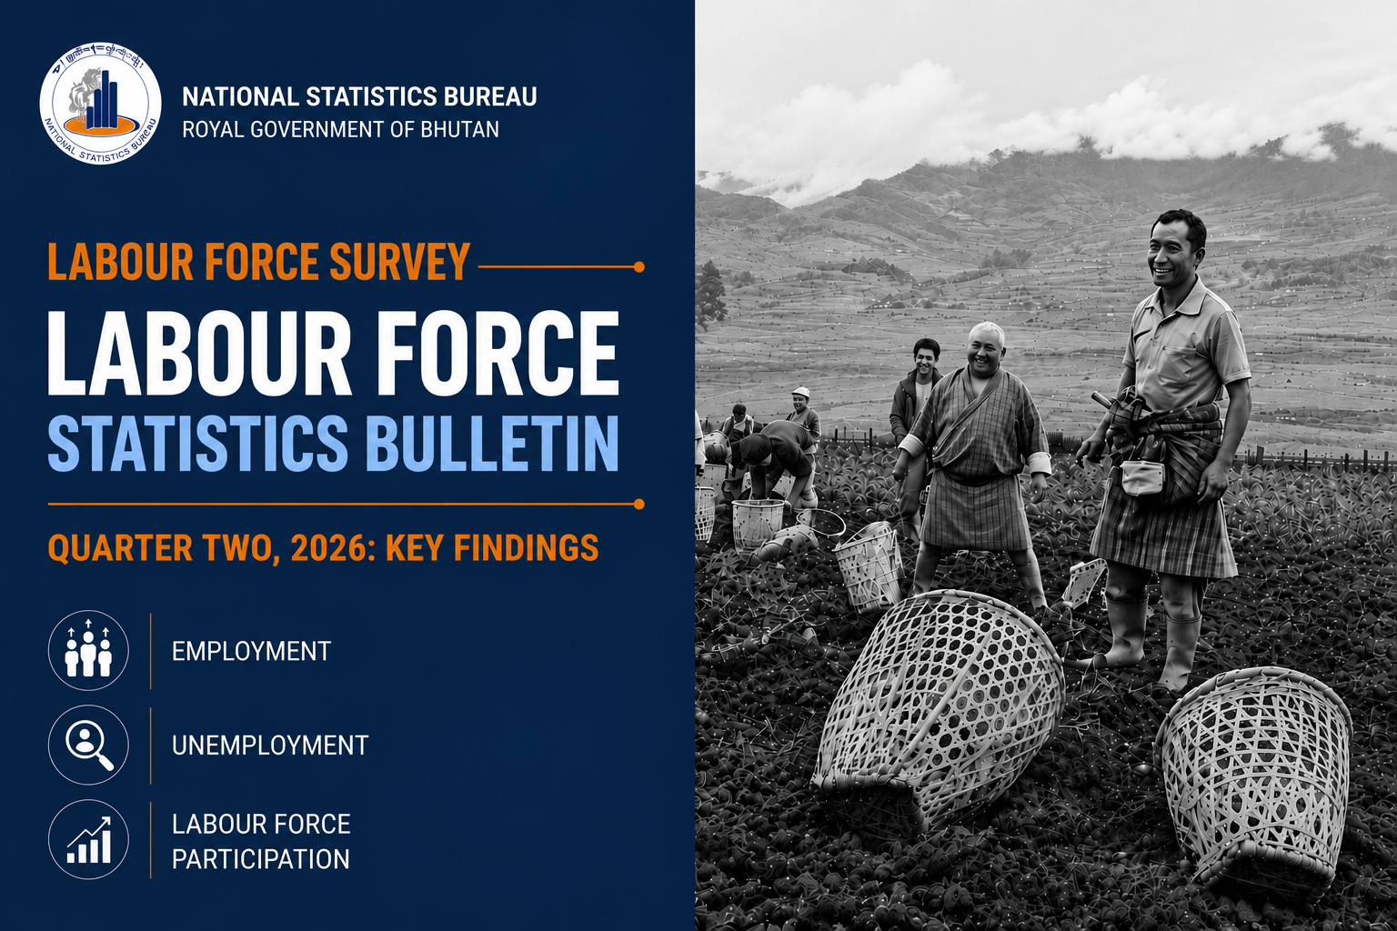
BACKGROUND

The Labour Force Survey (LFS) is an essential source of key labour market indicators used to guide national planning and policy decisions. The data generated supports the monitoring of economic performance and informs the development of employment programmes, poverty reduction strategies, and other socio-economic policies.
The Q2 2026 Labour Force Survey was conducted in May 2026, covering 2,928 households across 19 dzongkhags. Of these, 2,831 households successfully participated, resulting in a high response rate of 96.7 percent.
The indicators are produced at the domain level due to the relatively small sample size, which can lead to high sampling variability and large standard errors at more disaggregated levels, thereby reducing the statistical reliability and precision of the estimates. The survey adheres to the labour force concepts and standards set by the International Labour Organization (ILO), ensuring that the results are comparable at the international level.

Table 1: Key Highlights of Labour Market Indicators
Key Indicator (%) | 2024 |  |  |  | 2025 |  |  |  | 2026
Key Indicator (%) | Q1 | Q2 | Q3 | Q4 | Q1 | Q2 | Q3 | Q4 | Q1 | Q2
Labour Force Participation Rate
Sex
Male | 72.8 | 72.5 | 75.7 | 74.0 | 73.3 | 73.5 | 74.2 | 72.7 | 73.9 | 73.5
Female | 54.1 | 50.0 | 53.5 | 54.6 | 54.4 | 56.3 | 55.8 | 55.8 | 56.0 | 55.8
Area
Urban | 58.8 | 56.7 | 59.1 | 61.0 | 59.8 | 60.7 | 61.1 | 59.3 | 63.4 | 59.2
Rural | 67.0 | 65.0 | 68.7 | 67.1 | 67.1 | 68.0 | 68.1 | 67.7 | 66.6 | 68.6
Total | 63.9 | 61.8 | 65.1 | 64.8 | 64.3 | 65.3 | 65.5 | 64.6 | 65.4 | 65.1
Inactivity Rate
Sex
Male | 27.2 | 27.5 | 24.3 | 26.0 | 26.7 | 26.5 | 25.8 | 27.3 | 26.1 | 26.5
Female | 45.9 | 50.0 | 46.5 | 45.4 | 45.6 | 43.7 | 44.2 | 44.2 | 44.0 | 44.2
Area
Urban | 41.2 | 43.3 | 40.9 | 39.0 | 40.2 | 39.3 | 38.9 | 40.7 | 36.6 | 40.8
Rural | 33.0 | 35.0 | 31.3 | 32.9 | 32.9 | 32.0 | 31.9 | 32.3 | 33.4 | 31.4
Total | 36.1 | 38.2 | 34.9 | 35.2 | 35.7 | 34.7 | 34.5 | 35.4 | 34.6 | 34.9
Employment Rate
Sex
Male | 96.0 | 96.9 | 97.6 | 97.7 | 97.3 | 97.6 | 97.8 | 96.9 | 97.0 | 98.1
Female | 95.7 | 95.5 | 95.8 | 95.6 | 95.1 | 96.5 | 95.3 | 95.0 | 96.1 | 96.3
Area
Urban | 93.4 | 94.3 | 94.9 | 94.5 | 94.3 | 94.6 | 94.6 | 92.5 | 94.6 | 94.5
Rural | 97.2 | 97.5 | 97.9 | 98.3 | 97.6 | 98.4 | 97.9 | 98.0 | 97.8 | 98.8
Total | 95.9 | 96.3 | 96.9 | 96.9 | 96.4 | 97.1 | 96.8 | 96.2 | 96.6 | 97.3
Unemployment Rate
Sex
Male | 4.0 | 3.1 | 2.4 | 2.3 | 2.7 | 2.4 | 2.3 | 3.1 | 3.0 | 1.9
Female | 4.3 | 4.5 | 4.2 | 4.4 | 4.9 | 3.5 | 4.7 | 5.0 | 3.9 | 3.7
Area
Urban | 6.6 | 5.7 | 5.1 | 5.5 | 5.7 | 5.4 | 5.4 | 7.5 | 5.4 | 5.5
Rural | 2.8 | 2.5 | 2.1 | 1.8 | 2.4 | 1.6 | 2.1 | 2.0 | 2.2 | 1.2
Total | 4.1 | 3.7 | 3.1 | 3.1 | 3.6 | 2.9 | 3.2 | 3.8 | 3.4 | 2.7
Youth Unemployment Rate
Sex
Male | 25.7 | 18.9 | 11.9 | 14.5 | 14.8 | 13.8 | 13.4 | 15.1 | 16.2 | 12.8
Female | 19.7 | 19.6 | 21.8 | 21.2 | 19.5 | 20.3 | 22.4 | 26.5 | 16.7 | 13.9
Area
Urban | 31.5 | 21.7 | 20.1 | 19.8 | 19.7 | 22.0 | 21.16 | 27.1 | 17.0 | 18.7
Rural | 17.9 | 16.7 | 13.8 | 15.5 | 14.3 | 12.8 | 15.18 | 16.0 | 15.9 | 9.5
Total | 22.9 | 19.2 | 16.5 | 17.7 | 17.1 | 17.3 | 17.8 | 20.6 | 16.5 | 13.4

SURVEY FINDINGS
I. Labour force participation rate remains stable at around 65%

In Q2 2026, 77.9 percent (612,042 persons) of the total population were aged 15 years and above, constituting the working-age population. Of this, about 52.3 percent were male and 47.7 percent female; 38 percent resided in urban areas and 62 percent in rural areas. A total of 398,192 individuals were economically active, with males accounting for about 59 percent and females 41 percent. Economic activity is higher in rural areas (65.6%) compared to urban areas (34.4%). The Labour Force Participation Rate (LFPR) the proportion of the working-age population that is economically active stands at 65.1 percent in Q2, 2026. The rate is higher among males (73.5%) than females (55.8%), and higher in rural areas (68.6%) than in urban areas (59.2%) (Figure 1b).
The Labour Force Participation Rate (LFPR) remained broadly stable over the period, with a slight upward trend. It increased from 63.9 percent in Q1 2024 to 65.1 percent in Q2 2026. On a year-on-year basis, LFPR decreased by 0.2 percentage points from 65.3 percent in Q2 2025 to 65.1 percent in Q2 2026, while on a quarter-on-quarter basis, it decreased by 0.3 percentage points from 65.4 percent in Q1 2026. The differences are not statistically significant.
Disaggregated by sex, LFPR trends indicate that male participation remained consistently higher than female participation throughout the period, with only minor fluctuations. Female participation, while lower, shows a gradual improving trend over time, suggesting a modest narrowing of the gender gap (Figure1a).
By area, LFPR in rural areas remained higher than in urban areas across all quarters. While both areas exhibit some fluctuations, the overall trend suggests stable participation with a slight improvement over time, particularly in urban areas (Figure 1b).
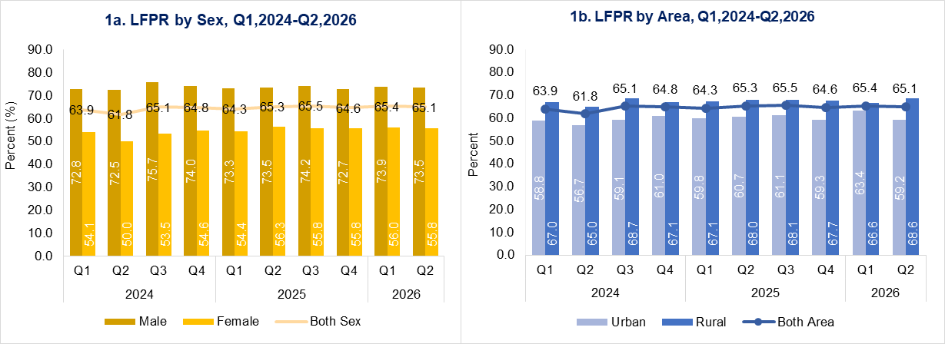
II. Education and family responsibilities continue to be the main reasons for being outside the labour force.

In Q2 2026, the proportion of persons outside the labour force increased by 0.3 percentage points compared to the previous quarter. On a year-on-year basis, the inactivity rate increased by 0.2 percentage points, from 34.7 percent in Q2 2025 to 34.9 percent.
The inactivity rate remains higher in urban areas (40.8%) than in rural areas (31.4%). A significant gender disparity persists, with female inactivity at 44.2 percent-18.0 percentage points higher than the male rate of 26.5 percent-reflecting continued gaps in labour force participation (Figure 2a).
As in the previous quarter, education and family responsibilities remain the main reasons for being outside the labour force. Most males reported studies or training as their primary reason, while females predominantly cited household and family duties, underscoring a persistent gender divide in labour force non-participation. Additionally, about 17 percent of those outside the labour force reported retirement or pension as their reason (Figure 2b).
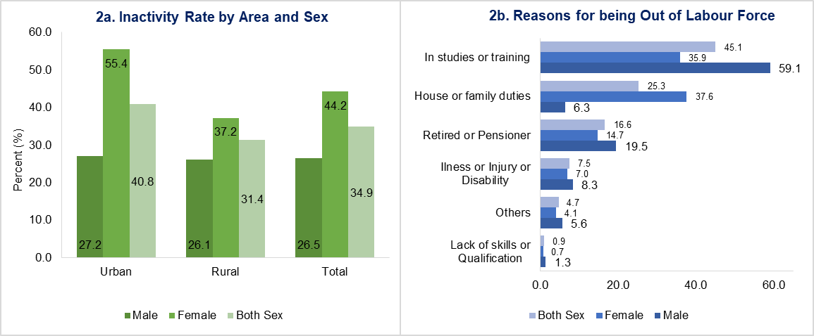
III. Employment rate remains consistent across quarters, with no statistically significant change observed.

In Quarter 2, 2026, the overall employment rate stands at 97.3 percent, showing a slight increase from 96.6 percent in the previous quarter. Compared to the same quarter last year, the rate is also slightly higher, reflecting minor fluctuations in employment.
The employment rate stands at 98.1 percent for males and 96.3 percent for females. By area of residence, the urban (94.5%) employment rate is lower than that of rural areas (98.8%). This is due to the engagement of the high proportion of rural residents in own-account agricultural work, particularly farming on their own land (Figure 3a).
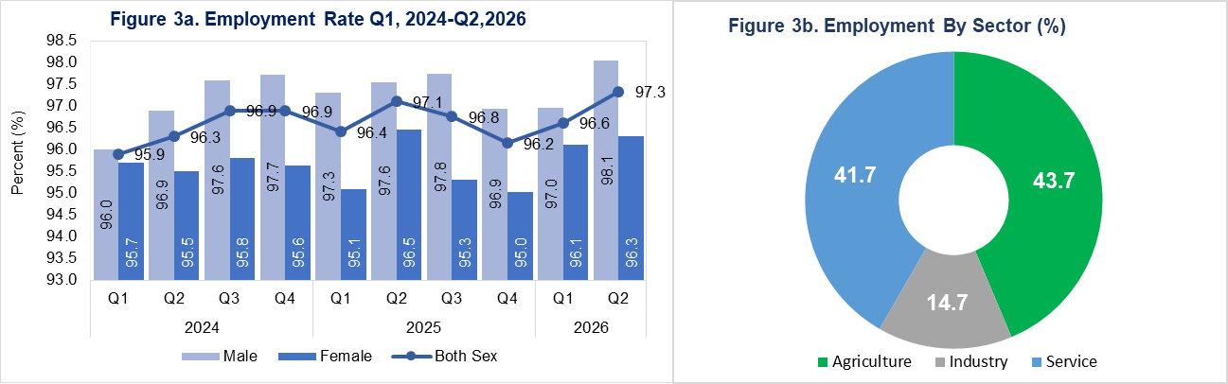

Among the 387,606 employed persons, 43.7 percent are engaged in the agriculture sector, 41.7 percent in the services sector, and 14.7 percent in the industry sector. Among employed males, a higher proportion are engaged in the services sector, whereas among employed females, a higher proportion are engaged in the agriculture sector (Figure 3b).

In Q2 2026, the distribution of employment shows that about 39.5 percent of the employed population were paid employees, including both regular and casual workers. Own-account workers, engaged in agricultural and non-agricultural activities, made up 35.0 percent, while contributing family workers accounted for approximately 25.5 percent of total employment. A notable gender disparity is observed across these employment categories, indicating differences in the nature of work undertaken by men and women (Figure 4a).
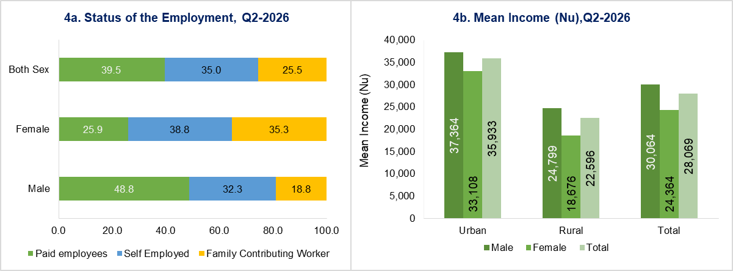
The average monthly labour income for employed persons is Nu. 28,069. Male employed persons earn a mean income of Nu. 30,064, which is Nu. 5,701 higher than that of female employed persons. This gap persists across both urban and rural areas, where males consistently report higher average earnings than females (Figure 4b). The median monthly income is Nu. 25,000, indicating that half of employed persons earn below this level.

IV. Overall unemployment rate remains at 2.7%, with youth unemployment continuing to remain substantially higher at about five times the overall rate.
In quarter two 2026, the national unemployment rate stands at 2.7 percent (95% CI: 2.1, 3.2), slightly lower than 3.4 percent (95% CI: 2.7, 4.0) in Quarter 1, 2026. The overlapping confidence intervals indicate that the observed difference is not statistically significant.
Compared to the same quarter in 2025, the rate is 0.2 percentage points lower. By sex, the unemployment rate is 1.9 percent for males and 3.7 percent for females (Figure 5a).
While the overall unemployment rate indicates near full employment, youth unemployment remains a persistent concern. Of the total unemployed persons actively seeking and available for work in Quarter 2 of 2026, 39.1 percent were youth aged 15-24. The youth unemployment rate stands at 13.4 percent (95% CI: 8.8, 18.0), reflecting a 3.1 percentage point decrease from the previous quarter. On a year-on-year basis, the rate increased by 3.9 percentage points compared to the same quarter of the preceding year (Figure 5b).
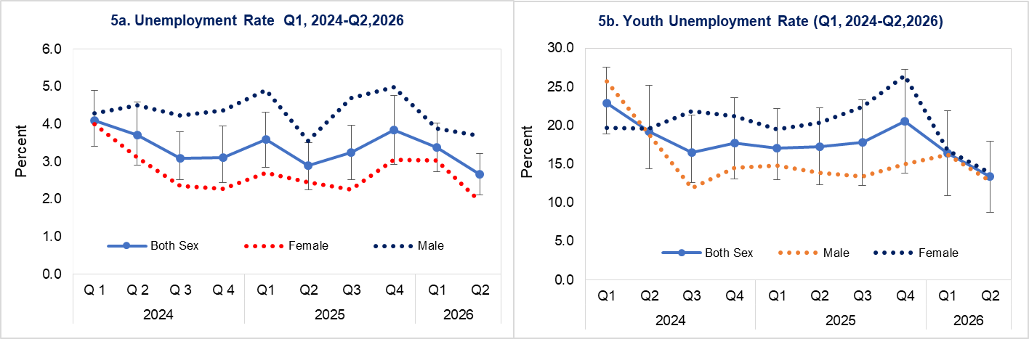
The unemployment rate is higher among younger age groups. It remains above the overall unemployment rate until the 30-34 years age group, after which the unemployment rate declines steadily and flattens from age 50 onwards (Figure 6a).
Similarly, the number of unemployed persons peaks in the 20-24 years group before declining thereafter. This decline in unemployment rate with age may reflect typical life-cycle patterns of labour market entry, accumulation of work experience, and increasing job stability.
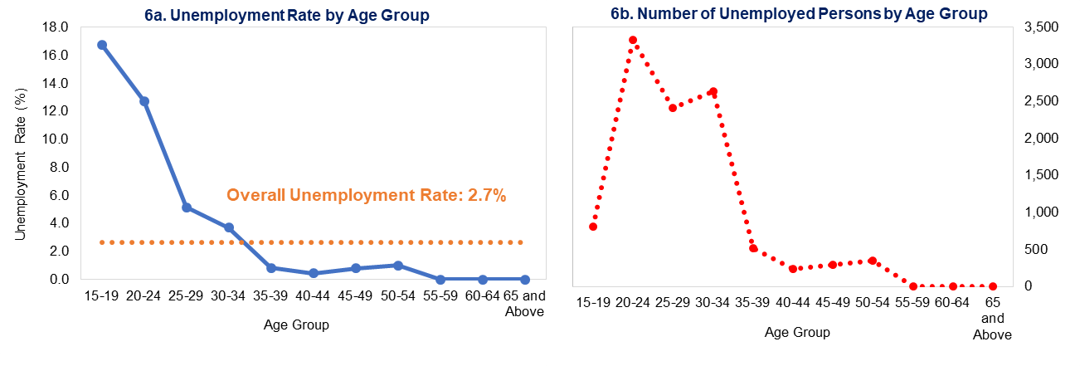
Information on reasons for unemployment shows that among several cited causes, the major ones include recently completed studies (32.4%), lack of skills (12.4%), qualification mismatch (12.3%), lack of adequate qualification (11.6%), lack of experience (9.9%) and voluntarily resigned (9.0%) (Figure 7a). Overall, these factors are similarly observed among both male and female unemployed persons, indicating that men and women face comparable challenges in the labour market.
Among the actively unemployed, 65.9 percent had been without work for less than six months, while the remaining 34.1 percent had been unemployed for six months or more. Within this latter group, about 15.4 percent of all unemployed persons had been jobless, actively seeking work, and available for employment for more than one year during the reference period. This group is classified as long-term unemployed (Figure 7b).
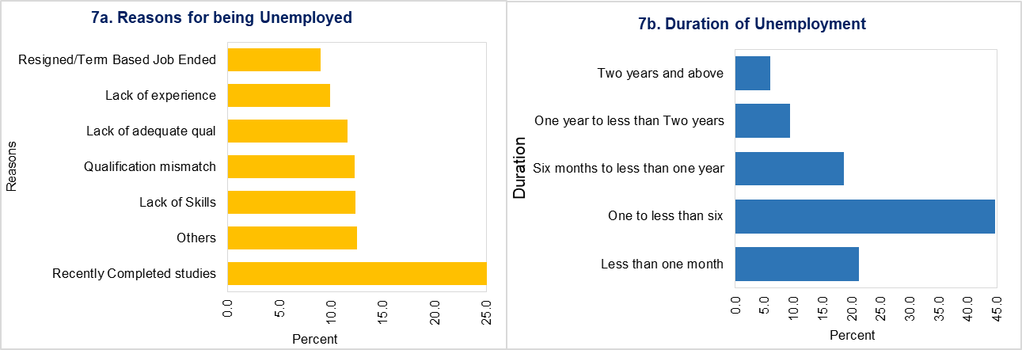

LABOUR FORCE STATISTICS BULLETIN
Published by National Statistics Bureau
P.O. Box 338
Tashichhodzong premises
Thimphu, Bhutan

